*The University of Texas Rio Grande Valley*

*College of Engineering and Computer Science*

Department of Mechanical Engineering

MECE 4361

Senior Design I

Fall 2016

Report Analysis for

**Second Generation Multi-Station Creep Tester**

Prepared for:

Kamal Sarkar, Ph.D.

Robert E. Jones, Ph.D.

Samantha J. Ramirez, MSE

By:

Rolando Garcia, Ricardo O. Jacome

Jon P. Stutz & Jose O. Moya

Due Date: December 8, 2016

Date Received: __________

Abstract

### Conducting creep test determines the behavior of certain materials at a specified stress and/or temperature. Creep testing has become a common procedure used by engineers in the field. There exists no creep machine that allows for multi-station testing, thus allowing for fewer tests to be conducted. It is possible to address these issues by engineering a second generation multi-station creep machine for testing of polymer materials. Current creep testing machines are available with high temperature chambers, that test metals and rarely non-metal materials. The price for polymer creep testers ranges from $4,000 to $15,000 and are designed for a single sample. Due to the design restrictions, running several tests at a time makes it costly and inefficient. The solution to this problem is the *Poly-Creep V*. This machine will be at maximum $3,000, which is about 70% less on average than the price of any creep tester on the market. This will allow for broader applications in industry and research improvement regarding high temperature polymer testing.

Table of Contents

Problem Formulation 5

Introduction (Elevator Speech) 5

Market Research 5

Competitive Products 6

Needs, Wants, and Constraints 7

Goals and Objectives 8

Quality Function Deployment (QFD) 8

Concept Selection 10

Methodology 10

Concept Generation/Potential Solution 11

Functional Decomposition 12

Sub-Functions 13

Design Constraints for each Sub-Function 16

Concept Variants for each Sub-Function 16

Selection Process by Pairing Method for each Sub-Function 16

Final Selection of all Sub-components 16

Proposed Solution 17

Detailed Drawings with Dimensions, Units, & Labeling 18

Design Embodiment 18

Proposed Design Highlighting Critical Features and Components 19

Engineering Analysis 19

Assumptions, Equations, Parameters of Interest, Boundary and Initial Conditions 19

Solution Strategies & Methods 21

Solutions, Results, and Related Graphs 22

Final Choices for Materials, Dimensions, and Pertinent Key Parameters 25

Design 25

Manufacturability 25

Safety 26

Environment, Reliability, Maintainability, etc. 26

Bill of Materials 30

Engineering Economics 30

Cost of Prototype 32

Production Cost 32

Manufacturing Process Details 32

Design Validation 32

Design Failure Mode and Effects Analysis (DFMEA) 32

Test Protocols 34

Design Documents 34

Engineering Calculations 34

Manufacturing Process 34

Various Materials (User’s, Maintenance, Operations, etc.) 34

Summary 34

References 35

Appendices 35

Nomenclature

*A* = area

*Bi* = Biot number

*Cp* = specific heat

*F* = force

*F.S.* = factor of safety

*h* = height

*k* = thermal conductivity

*L* = length

*N* = number of gear teeth

*P* = pitch

*r* = radius

*Re* = Reynold’s number

*T* = temperature

*t* = time

*V* = velocity

*W* = weight

Greek

*∀* = volume

*α* = coefficient of thermal expansion

*δ* = displacement

*ϑ* = kinematic viscosity

*μ* = dynamic viscosity

*ρ* = density

*σ* = stress

*τ* = torque

# Problem Formulation

## Introduction (Elevator Speech)

### Conducting creep test determines the behavior of certain materials at a specified stress and/or temperature. Creep testing has become a common procedure used by engineers in the field. As technology advances so does the materials being implemented to create these new emerging technologies. Polymers, both lightweight and durable, are being used more in industry at higher temperatures so creep behavior is critical. There exists no creep machine that allows for multi-station testing, thus allowing for fewer tests to be conducted. We believe it is possible to address these issues by engineering a second generation multi-station creep machine for testing of polymer materials.

### Current creep testing machines are available with high temperature chambers, that test metals and rarely non-metal materials. The price for polymer creep testers ranges from $4,000 to $15,000 and are designed for a single sample. Due to the design restrictions, running several tests at a time makes it costly and inefficient.

### In order to assess this problem, we propose to build a creep machine that allows for multiple specimen testing. This will include a tensile/compressive/flexure mechanism, programmable export interface, and consistent temperature chamber. Through the use of LVDTs and thermocouples, the accuracy of the device will be improved. It will be designed to be easily transported and have a friendly user interface. After consideration, we decided that the Poly-Creep V would be the most appropriate option.

### The Poly-Creep V will be at maximum $2500, which is about 70% less on average than the price of any creep tester on the market. The Poly-Creep V will be the first of its kind to house 5 specimen stations allowing for maximum statistical advantage. This will allow for broader applications in industry and research improvement regarding high temperature polymer testing.

## Market Research

### For the market research, several constraints were taken in count such as the type of Creep Testing Machines that analyzed the same types of materials, polymers, such as the Poly-Creep V will test. For a polymer creep testing machine, the market margin is about $45 million in the current market. This value is due to the types of testing the machine will be able to perfume, as previously mentioned this test will be Tensile, Compression, and Flexure tests.

### In the current market, the price of a Polymer Testing Machine can range from $4000 to $15,000, approximately, per unit. This prices were investigated comparing several companies which objectives are to manufacture test equipment to evaluate the mechanical properties of materials and components. Some companies that can be consider as competitors for the Poly-Creep V are *MTS Systems Corporation, Instron,* and *ATS.*

### Such companies are considered for general testing equipment, further more examination indicates many other companies that focuses on polymers’ creep behavior. With this additional investigation the following chart was able to be constructed.

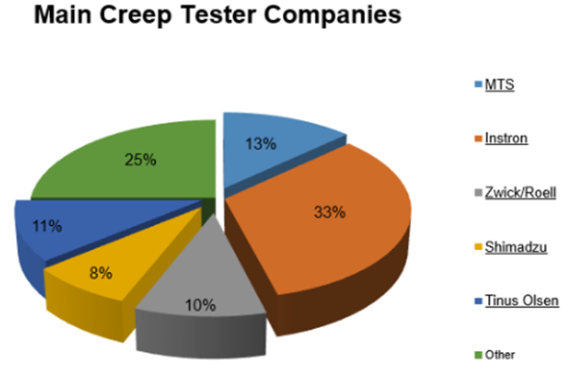

### In this chart, a quarter of the whole market is composed of small companies that some of their equipment is for the creep testing of polymers. In the other side, one third of the market is controlled by *Instron*, one of the companies that was consider to be one of the major competitors for the Poly-Creep V.

## Competitive Products

### In such a big market, several competitors were selected to be compared with the Poly-Creep V, in such way that the constraints for it were able to make of if a good challenger in the market. Such competitors are in the following table, where the company name, the product, price, and additional information are presented.

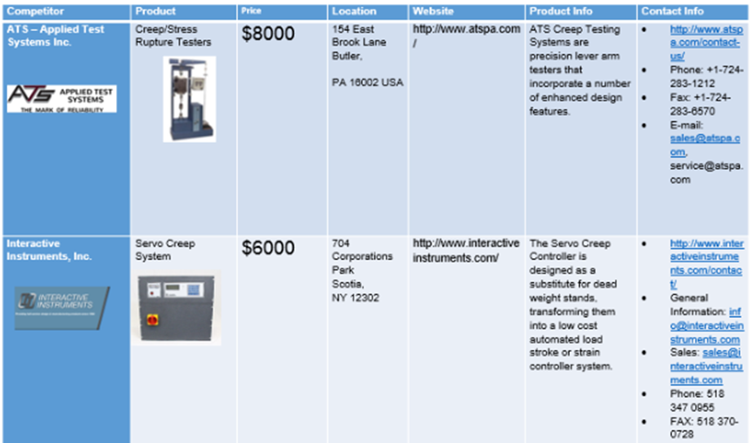

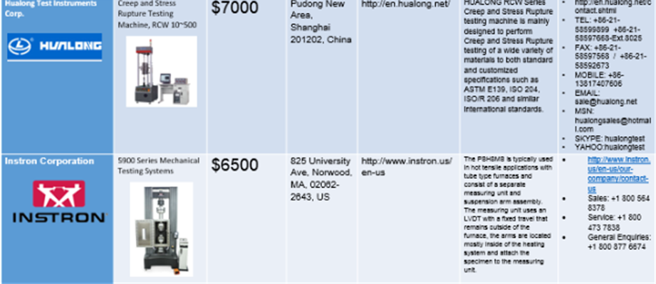

## Needs, Wants, and Constraints

### The list of the Needs includes:

### Mobility

### Multiple Polymer Testing

### Quick Output Response

### Constant Loading

### This previous list is based from the upgrades and fixing that is required from the previous creep tester machine. Thus, the needs list has to be totally implemented into the device.

### The list of the Wants includes:

### Aesthetic Appeal

### Inexpensive

### User Friendly

### Interchangeable Parts

### This aforementioned list contains sections that are not necessary to have a successful product but would still improve the quality and appeal for customers to buy the Poly-Creep V.

### Finally, the main constraints encountered for each subcomponent will be mentioned within each subcomponent section. However, the overall constraints that all sub-components have are time and money which will be a driving factor for every part selection.

## Goals and Objectives

### For the goals, it was needed a device that is financially feasible, user friendly and able to provide different types of data.

### Whereas the objectives involve three modes of creep testing, static loading mechanism, reaching steady state equilibrium and calibrating data from Arduino into Excel and/or MATLAB.

## Quality Function Deployment (QFD)

### The Quality Function Deployment is a visual and structural approach to defining customer needs and translating them into a plan of action to produce products to meet those needs.

### Macintosh HD:Users:prestonstutz:Desktop:Screen Shot 2016-11-18 at 4.08.55 PM.png

### In the chart above, the customer’s needs are mobility, multiple polymer testing stations, multiple testing methods, a quick output response, and to be subjected to constant loading. These are succeeded by the customer’s wants, which are aesthetic appeal, to be inexpensive, user friendly, and to have interchangeable parts. The customer’s needs are by far more important than the wants, which will only be fulfilled if all the needs are met first.

### In the following columns to the right of the needs and wants reside the engineering design parameters, which are actuator displacement, temperature range, weight system, grip clearance, constant temperature chamber, input voltage, output plot, thermo-resistant camera, and cost. The needs, wants, and engineering design parameters are all initial conceptual ideas that came about in the early phases of market research and design that may be subject to change as the project nears completion.

### Even further to the right of the design parameters lies the comparison of the Poly-Creep V amongst other competitors in the polymer creep testing market. The following companies are being compared: Applied Test Systems, Interactive Instruments, Instron Corporation, and Hualong Test Instruments Corporation. The columns beneath each company relate how well the company meets the needs of its customers. While many of the other creep testing machines on the market cater to specific niches, the Poly-Creep V is designed to encompass the vast majority of the customer’s needs and wants.

### The lower portion of the QFD shows the obtainable engineering parameters with respect to each company. The Poly-Creep V has the majority of the parameters filled out because this project is catering to all the needs, whereas some of the other companies were only concerned with specific needs.

### The very top portion of the chart depicts positive and negative correlations of the engineering design parameters with respect to one another. The cost generally had a negative correlation with most of the optimized design parameters. Ultimately, the QFD is utilized to get the most expansive outlook possible on the market, narrowed down to specific needs of the customer for use at the university level.

# Concept Selection

## Methodology

### The concept selection involves the steps taken into account in order to select the subcomponents that will take part into making the final product. For this product, the idea is to create a multi-station creep tester machine which will involve the following: Create a grip system that will hold in place polymer samples in order to prepare them for testing. Also a weight application mechanism is needed in order to apply a quasi-static load into the polymer samples in order to initiate molecular movement. Furthermore, a heating chamber is needed in order to create creep on the samples. Finally, it is needed to have a sensor system that will record the temperature, time and displacement values from the experiment and will export it into experimental data that can be used by students in order to study creep behavior.

### The first step to design this machine involves doing a concept generation with potential solutions for making a creep testing machine. Afterwards the main product which is the Poly-Creep V is divided into its main sub-components which are discussed in the functional decomposition. Then all of the sub-components are analyzed to see which different options can be used to fulfill the sub-component purpose. In example, if one of the sub-components is a temperature sensor, it is necessary to analyze all possible options that can give temperature readings. Then, the design constraints and concept variants are analyzed for every sub-component. Finally, by comparing all the aforementioned parameters, a final selection is made for the sub-component that will take part into the final design.

## Concept Generation/Potential Solution

### The following figure is a picture of the past creep tester worked on by a senior design group in 2014. The main components of the design are labeled.

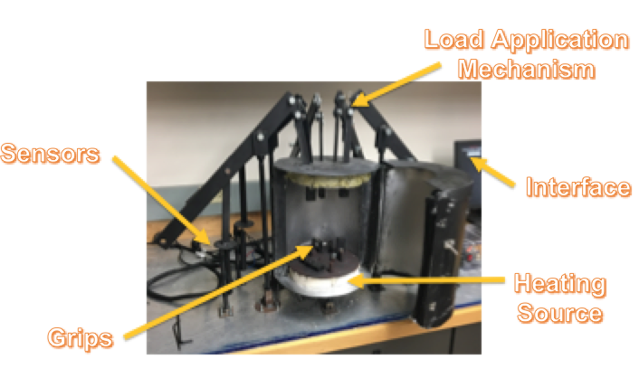

### It was noted that there was quite a bit of issues with a few of the components in the previous design. There is a list of the design parameters and the respective issue with each in the following figure.

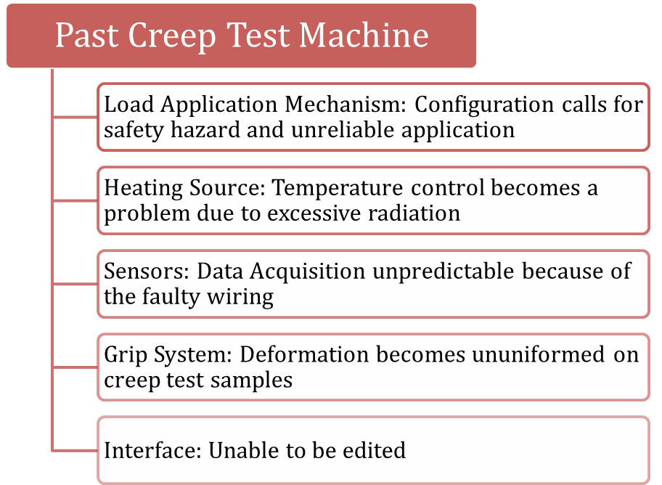

### The previous load application called for an individual to hold and operate the weight dropping apparatus as it attempted to undergo quasi-static loading. This was not only an inconvenience, but also a safety hazard for anyone conducting a lab. It also brought humans into the equation, making constant loading a lost cause. Radiation was used as the main source of heat transfer within the furnace, which caused the furnace to fluctuate greatly at times. The wiring on the thermocouples and potentiometers was fastened to the surfaces of the weight application mechanism with Velcro, which was fidgety and caused inaccurate readings to be obtained. The grip system was designed so that a single screw at the top of the furnace pinched the polymer sample and once heated up to the appropriate temperature, the screw would sometimes penetrate the specimen. Finally, the LabVIEW interface did not allow for changing of the input voltage.

### The proposed solution consists of the following key points that will go into design:

### Multiple Specimen Testing (5 samples)

### Tensile, Compressive, and Flexural Creep Testing Mechanisms

### Friendly User Interface

### A Constant Temperature Heat Source

### Easily Transportable

## Functional Decomposition

### Macintosh HD:Users:prestonstutz:Desktop:Screen Shot 2016-11-25 at 6.58.21 PM.png

### The above diagram lists each functional component of the Poly-Creep V design and the relationship between one another. The heat chamber, grip type, weight mechanism, and sensors exhibit a cyclical relationship because they all contribute to the constant loading and temperature gradient that are necessary to be experienced by the polymer test samples in order to produce valid creep constant results. The heat chamber is the main component where the sample will be contained at constant temperature. The grips will remain in the heating chamber to secure the sample at the top and bottom. They will also support the free hanging weight mechanism that will be below the heating chamber, which consists of a long rod with a hook at the end that will hold a predetermined amount of weight based on the sample being tested. Sensors will be place at the bottom of the free hanging weight (linear potentiometers), as well as inside the heating chamber (thermocouples) on each sample. These sensors will then output a voltage measurement through a wiring box containing two Arduino chips that will convert the signal into well-known engineering parameters such as displacement, time, and temperature, which will produce plots of creep constants in Excel.

## Sub-Functions

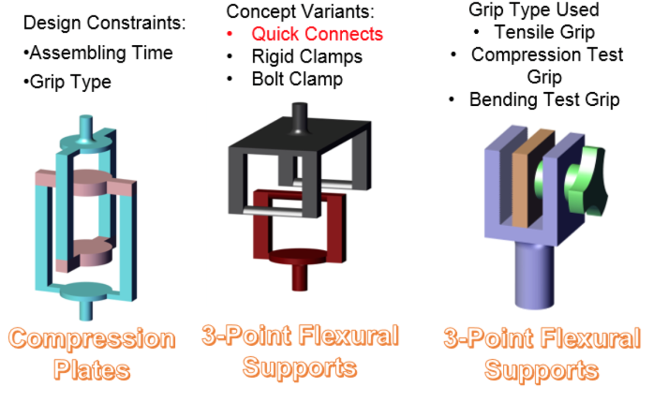

### The most important factor related to the grips is the typed used which are based on the three modes of testing that will be conducted with the Poly-Creep V. The modes are as follows: tensile, compressive, and bending. These three modes of creep testing will be the main requirements for the grip apparatus, as they will function as three interchangeable testing surfaces, allowing the user to easily run whatever type of test they would like. It is these three different grip types, as well as the amount of time taken to manufacture the grip plates that make up the constraints. Concept variants consist of rigid clamps, bolt clamps, and quick connects. All of which can be manufactured or bought at a local hardware store.

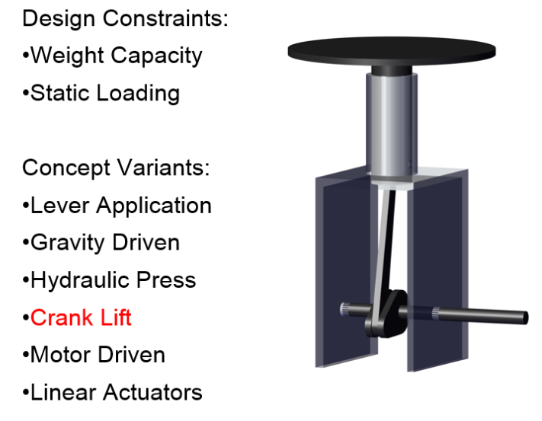

### The top two constraints that come into play when designing the weight mechanism are static loading and weight capacity. Weight capacity involves the weight of all 5 specimen rods and respective hanging free weights that will be acting on each polymer specimen. Static loading will be obtained through concept variants such as constant speed motor, crank, lever, or linear actuator. Otherwise the process will be carried out through gravity taking effect on hanging weights. No human interaction would be necessary in the weight dropping process if gravity were to be selected.

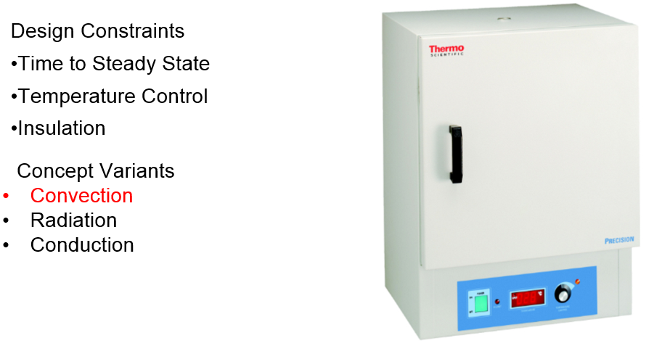

### The heat chamber is the single sub function that has the most variance in the functional decomposition. It involves the only variable, temperature, in which there is uncertainty in the range of coverage. There is also uncertainty whether or not the temperature is completely uniform throughout the entirety of the chamber. Testing will be done on this with thermocouples in order to ensure proper heat transfer is maintained within the chamber. Design constraints involve how much time the chamber takes to get to steady state, control of the range of temperature, and insulation throughout the bottom of the chamber where holes will be drilled for specimen loading. Types of oven concepts that will considered are convection, radiation, and conduction. Previously the furnace was heated through radiation by nichrome wire. Work is being done to calculate whether or not that is the best means of heat transfer for polymer testing.

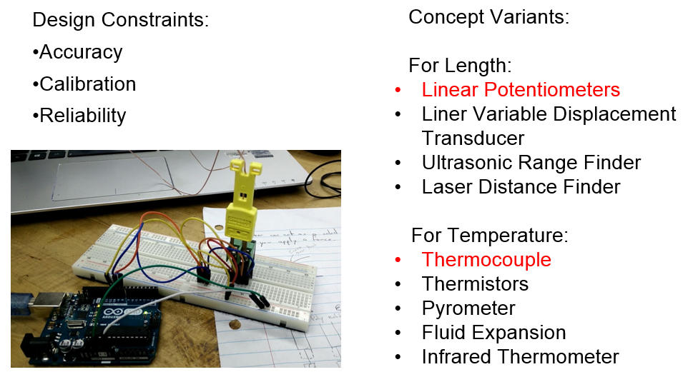

### Design constraints for the first portion of the data acquisition process involves accuracy of the reading, calibration of the sensors if needed, and reliability of the readings when compared to engineering literature. Two types of sensors will be used for the creep testing application: displacement and temperature. For the displacement application, types of sensors being considered are linear potentiometers, LVDTs, ultrasonic range finders, and laser distance finders. Potentiometers and LVDTs are the most likely candidates because of their affordability. Sensors used for temperature involve thermocouples, thermistors, pyrometers, fluid expansion apparatus, or infrared thermometers.

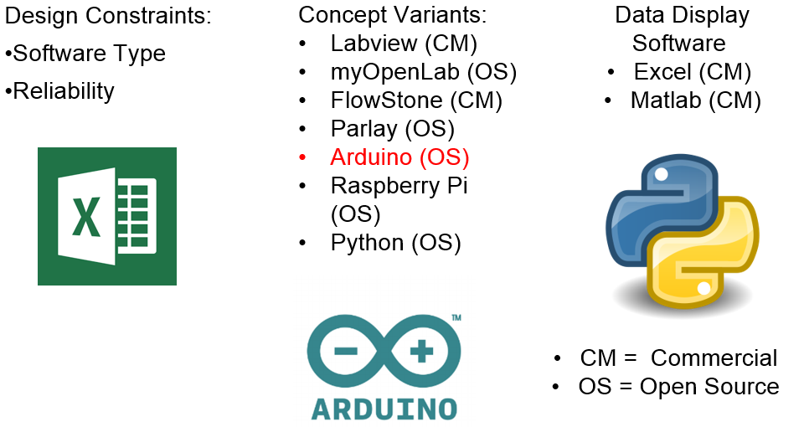

### The second half of the data acquisition involves the interface, which will collect and process the data from the sensors into readable engineering variables. Design constraints for the interface are software type and reliability of collected data when compared to engineering literature. Concept variants involve several commercial and open source variants such as LabVIEW, MyOpenLab, Flowstone, Parlay, Arduino, Raspberry Pi, and Python. These concept variants will provide a gateway for the two display interfaces: Excel or MATLAB.

## Design Constraints for each Sub-Function

## Concept Variants for each Sub-Function

## Selection Process by Pairing Method for each Sub-Function

## Final Selection of all Sub-components

### Grip Type: Quick Connects

### Quick connects were chosen over rigid, stationary clamps because of their ease of accessibility, cheap price in hardware stores, and ability to come as a rotary joint. This will allow the specimen to self-align as it is pulled downward from the weight applied by the bottom grip.

### Weight Mechanism: Crank Lift

### The crank lift provides for constant loading weight application by allowing the user to control the rate of speed through a gear reducing mechanism. Angular speed is held constant and at low speeds to ensure proper loading of the polymer. This provides the user, university students, the ability to interact with the machine and help them to understand the concept of creep and its relationship to constant loading.

### Heat Chamber: Convection

### Having a forced convection heat chamber allows for a more uniform overall temperature to be distributed within the chamber. The heating element consists of a fan blowing and distributing warm air, as opposed to the radiation oven that needed a heating element such as Nichrome wire in the previous creep tester setup. That type of heating didn’t allow for wire to be layered throughout the chamber, so uneven heating was obtained as a result.

### Sensors: Linear Potentiometer/Thermocouple

### Linear potentiometers beat out the majority of competitors besides laser distance finders for accuracy and precision. However, laser distance finders are extremely high in price. The linear part of the potentiometer was exactly what the design called for. This allows one to vertically displace an amount up to 5 inches, which should be more than enough displacement for proper creep recordings to be taken. The thermocouple was chosen over the other concepts because of the familiarity with it from use in engineering labs. The other options were being also extremely high in price and the accuracy is not that much better.

### Interface: Arduino/Excel

### Data acquisition came down to what a team of mechanical engineers would be most familiar with. Excel is used on a daily basis by the majority engineers and provides decent plots with optional regression analysis. It is simple for any new student to pick up and would be perfect to implement as the trial software. The Arduino has a simple coding interface that allows one to change inputs and use mathematical conversions to produce multivariable plots. It is easy to wire and has a 5 V minimum requirement for the thermocouples and potentiometers to run in parallel.

## Proposed Solution

### 

### The above figure has the final outline for the Poly-Creep V’s design. It’s modeled after the previous creep tester pictured earlier with modified components. Each sub component is shown here with respect to the entire functional decomposition. A heating source is situated on top of a transportable cart that will have locking brakes. The heating source has five holes drilled through the bottom of the furnace as shown in the grip section. Through these holes, a constant load apparatus will be left to sit on the crank lift platform. The constant load apparatus consists of ¼ inch aluminum rods attached to grips at the top and weights at the bottom. The grips at the top will hold the polymer specimen, while the weights at the bottom will wait to be manually lowered as a person turns the crank. A gear box is situated just below that crank lift platform and houses a gear reducing setup. Thermocouples are connected to a place near each polymer testing sample to monitor the temperature that the specimen is undergoing. The linear potentiometers will be connected to the bottom of the crank lift and each will be allowed to displace due to the applied force. These sensors will be wired to a box containing two Arduino chips and breadboards. Finally, a wire will be directed from the box to the computer interface that will output data in excel. The wiring box, as well as a barrier between the heat chamber and the computer will be made from acrylic bought from the local hardware store.

Detailed Drawings with Dimensions, Units, & Labeling

# Design Embodiment

## Proposed Design Highlighting Critical Features and Components

# Engineering Analysis

### The weight lift mechanism is analyzed using kinematics and dynamics of machines. Using stress analysis, torque amplification, gear reduction ratios, and impact force appropriate dimensions and materials to be used in the crank lift mechanism can then be determined.

## Assumptions, Equations, Parameters of Interest, Boundary and Initial Conditions

### The maximum weight to be applied to each creep testing specimen is set to be 10,000 grams, and every specimen thereafter is to have at least a 500-gram difference. Here the total weight applied to the specimens is then used to calculate stress analysis on a nominal cross-sectional area for the crank lift mechanism. The stress applied is then used for necessary torque applied calculations. The clearance height from the bottom of the heating chamber to the base of the lifting mechanism is then used for design for failure calculations. From biomechanics research, we assume here that the average pushing/pulling force of a human arm is 25 lb. The assumptions and equations used are as follows.

$$1 gram=\frac{1}{453.6} lb$$

$$S_{1}=10,000 grams=22.05 lb$$

$$S_{2}=9,500 grams=20.94 lb$$

$$S_{3}=9,000 grams=19.84 lb$$

$$S_{4}=8,500 grams=18.74 lb$$

$$S_{5}=8,000 grams=17.64 lb$$

$$torque=τ=rF$$

$$\frac{T_{1}}{T_{2}}=-\frac{N_{1}}{N_{2}}=\frac{ω_{2}}{ω_{1}}=-\frac{D_{1}}{D_{2}}=GR$$

$$F_{e}=W\left(1+\sqrt{1+\frac{2h}{δ_{st}}}\right)$$

$$stress= σ=\frac{Force}{Area}$$

$$average human push/pull force=25 lb$$

$$factor of safety=\frac{yield stress}{working stress}$$

### The thermal expansion of the rods for the weight mechanism was consider for the material selection of this ones, also for the decision to implement linear bearing to align the rods once they are attached to the testing machine. The following equation is for the thermal expansion of a material.

$$\frac{∆L}{L}=α_{L}∆T$$

$$\frac{∆A}{A}=α_{A}∆T$$

$$\frac{∆V}{V}=α_{V}∆T$$

### Another parameter to take in count in order to select the rod material and its dimensions, is the Factor of Safety (F.S.) according to the yielding stress of different materials.

$$Factor of Safety= \frac{σ_{Yield}}{σ_{Allowable}}$$

$$σ=\frac{F}{A}$$

$$A=\frac{π}{4}D^{2}$$

### Using the equation of F.S., two methods were used; one where the factor of safety was calculated using a specified diameter with the maximum applied load that the specimens will be tested with. The other method is specifying the maximum desire factor of safety that the rods also with the maximum applied load, and solving for the minimum required diameter of the rods for the Poly-Creep V.

$$D=\sqrt{\frac{4*FoS*F}{π*σ_{Yield}}}$$

### In order to analyze the chamber and the grips of the Poly-Creep V, the calculations were taken in count maximum temperature of the chamber, which is approximately 220 °C. Also considering that the selected oven for the testing machine is forced-convection oven, the volumetric flow and the properties of the air at the maximum temperature will be needed to take in consideration, such as its density, specific heat, the *Prandtl*, *Nusselt*, and *Biot* number.

$$\frac{T-T_{∞}}{T_{i}-T_{∞}}=exp\left[-\left(\frac{hA_{s}}{ρVC_{p}}\right)t\right]$$

$$Bi=\frac{hL_{c}}{k}$$

$$Re=\frac{ρVL_{c}}{μ}=\frac{VL_{c}}{ϑ}$$

$$\overline{Nu}=\frac{\overline{h}L_{c}}{k_{f}}$$

## Solution Strategies & Methods

### The solution strategy used for the weight lift mechanism is then rooted at the load application position. Since the loads will be applied to the rods directly connected to the specimens, the weights are then held in place by the weight lift mechanism, which is where the stress application and torque calculations are derived from. The impact force designed for failure is analyzed at the largest clearance for worst case scenario applications.

### In order to analyze the thermal expansion and the heat distribution for the parts and the chamber of the Poly-Creep V, the calculations were made in two different methods. The first one, providing a minimum F.S. depending on the allowable yielding stress of each possible materials in order to determine the maximum minimum dimensions for the parts. In order to have an acceptable F.S., the minimum value for this one must be of 1.5. The second method, was to provide the possible dimensions of the parts and calculate the F.S. of each possible part according to its dimensions and the material selected for them. For example, in order to apply the load to the specimens, a rod is necessary to transfer the load, some materials taken in consideration were Aluminum Alloy 2014 – T6 and 6061 – T6 with a Yielding Stress of 60 ksi and 35 ksi; with the possible dimensions of ¼’’ and ½’’ in diameter.

### In order to support the calculations, a simulation done in Autodesk Mechanical Simulation 2017, which is a program that utilize the Finite Element Method Analysis in order to predict the results of a scenario that for this case it will be for the maximum temperature produced by the forced convection oven.

## Solutions, Results, and Related Graphs

### The engineering analysis solutions for the crank lift mechanism were obtained through the following calculations. The first is the total amount of torque produced from the weight applied to all five specimens combined.

$$W_{{total}_{max}}=45,000 grams=99.21 lb$$

$$crank arm radius=r_{crank arm}=2.5 in=0.2083 ft$$

$$τ_{1}=r_{crank arm}W_{{total}_{max}}=0.2083 ft×99.21 lb$$

$$τ_{1}=20.69 ft∙lb$$

### Here it can be seen that the max torque applied to the crank lift mechanism is then 20.69 ft-lb. From this data a gear reduction train can be designed that will amplify the torque input to provide the torque needed to lift and lower the max torque applied by the weights. Start first by the number of teeth in a three spur gear train with a pitch of 10.

$$N_{1}=60$$

$$N_{2}=30$$

$$N_{3}=10$$

$$pitch=10$$

### The max torque created by the weights applied is then used to verify an input torque needed to move the mechanism with ease.

$$τ_{2}=τ_{1}∙\frac{N_{2}}{N_{1}}=20.69 ft∙lb×\frac{30}{60}$$

$$τ_{2}=10.33 ft∙lb$$

$$τ_{3}=τ_{2}∙\frac{N_{3}}{N_{2}}=10.33 ft∙lb×\frac{10}{30}$$

$$τ_{3}=3.44 ft∙lb$$

### Thus the torque needed to move the mechanism is then 3.44 ft-lb. This torque can then be translated to a pushing/pulling force as follows.

$$gear crank arm radius=r_{gear crank}=2.5 in=0.2083 ft$$

$$force needed to crank=\frac{τ_{3}}{r_{gear crank}}=\frac{3.44 ft∙lb}{0.2083 ft}=16.54 lb$$

### From the input force generated from the human hand the weight lift mechanism lifting force can then be calculated. From the lifting force a dynamic factor of safety for the weight lift mechanism is produced.

$$τ_{generated}=0.2083 ft×25 lb$$

$$τ_{generated}=5.21 ft∙lb$$

$$F_{generated}=τ_{generated}∙\frac{N_{2}}{N_{3}}∙\frac{N_{1}}{N_{2}}∙\frac{1}{crank arm radius}$$

$$F_{generated}=5.21 ft∙lb∙\frac{30}{10}∙\frac{60}{30}∙\frac{1}{0.2083 ft}$$

$$F_{generated}=150 lb$$

$$factor of safety=\frac{F_{generated}}{F_{needed}}=\frac{150 lb}{99.21 lb}$$

$$factor of safety=1.5$$

### From the maximum clearance between the heat chamber and the crank lift mechanism a maximum impact force generated by the failure of weights which would generate an impact stress on the base can be determined. From this a factor of safety for failure of the rods or weights once testing is in progress from a selected material is calculated.

$$h=6 in$$

$$δ_{st}=0.1 in$$

$$F_{e}=99.21 lb\left(1+\sqrt{1+\frac{2(6 in)}{0.1 in}}\right)$$

$$F_{e}=1190.5 lb$$

$$Impact Stress=\frac{F_{e}}{A}=\frac{1190.5 lb}{\frac{3.58}{2}{in}^{2}}$$

$$Impact Stress=665.08 psi$$

### In order to support the calculations for the rods and grips used, a simulation done in Autodesk Mechanical Simulation 2017, which is a program that utilize the Finite Element Method Analysis in order to predict the results of a scenario that for this case it will be for the maximum temperature produced by the forced convection oven.







## Final Choices for Materials, Dimensions, and Pertinent Key Parameters

### The final design choices for the weight lift mechanism are affected by the resources and manufacturability readily available. The first choice for the intricate design manufacturing is fused deposition modeling, or 3D printing of parts. This choice if heavily affected by the mechanical properties of the material used in the process. Polylactic acid, or PLA filament for 3D printing was chosen due to its compressive mechanical properties. From the mechanical properties of PLA, it can then be determined if it is suitable for application under the implicated stresses and thus calculate a factor of safety.

$$compressive strength of 3D printed PLA=2600 psi$$

$$factor of safety=\frac{Strength}{Impact Stress}=\frac{2600 psi}{665.08 psi}$$

$$factor of safety=3.9$$

### From these calculations it was determined that the 3D printed PLA modeling method, is a suitable material for manufacturing all necessary parts of the crank lift mechanism.

### According to graphs # and #, the optimal choice of material for the rods would be Aluminum Alloy 2014-T6, since is the material that provides the highest F.S. of approximately 150 for a diameter of ¼”. Although since the material is aluminum that causes a higher thermal expansion, it was decided that the expansion is insignificant and will not affect the efficiency of the Poly-Creep V. Also, it was selected since it has a lower density compared to the steel family, and will contribute less to the weight of the Poly-Creep V compared to the steel materials.

# Design for:

## Manufacturability

### In order to design for manufacturability, the cited article [1] explains specific guidelines in which the Poly-Creep design meets the following criteria:

### Avoid right/left hand parts: This was done for the rod assembly, and grip system assembly.

### Design parts with symmetry: Mainly for the gear system, rods and grips.

### Design for fixtures: Grips and gears were designed for easily grip.

### Designing for tooling: Main tooling was done through 3D printing and CNC machining. Even though those pieces are expensive, it is possible to mass produce them with the same equipment rather than human assembly.

### Follow the rule of 10: compliance with the Rule of 10 is met.

### Minimize Setups: Machined parts only require one single setup.

### Minimize Cutting Tools: Cutting Tools are minimized in this process, only the rods will use cutting tools.

## Safety

### In order to account for safety into the Poly-Creep V, there has not been enough time and money to actually implement it into the final prototype. However, the ideas that are available to design for safety include an Arduino program, a displacement sensor, and a thermocouple. The idea for the Arduino program is an if-then statement that will trigger if, for example the displacement sensor exceeds the maximum displacement calculated for the weights. If this case is not achieved through the normal potentiometers, a special switch that will only act if the weight station goes down after a certain distance. The purpose for both potentiometer and switch will be to automatically shut off the machine with the if-then statement.

### Furthermore, for the thermocouple sensor, that one could be attached to a separate Arduino in case that the rest of the system fails. The purpose for this thermocouple would be to measure the overall temperature on the oven. If the temperature were to go higher than 400 Celsius (which is something that should not be reached in polymer testing), then the Arduino will prompt and automatic shutoff for the machine or in the worst case scenario, it will make a call or report to the responsible person using the machine to let them know that the temperature has reached a dangerous stage.

## Environment

### In the case of the environment, the Poly-Creep V has many components that can be recycled. In example the range of melting temperature for aluminum is around 600 degrees Celsius. This temperature is about twice the temperature that the polymers are being tested. Thus it is possible to obtain aluminum materials and recycle them in order to create the grip system in the Poly-Creep V.

### Using the design for environment protocols [1], the following guidelines for materials and extraction were followed:

### Avoid use of hazardous toxic or environmentally unfriendly materials.

### Use materials that are renewable, or recyclable.

### Design products in a way that reduces material use.

### Design for minimum waste production.

### The following which could be added on later design can be considered:

### Avoid Materials with a high energy content (i.e. Aluminum), but it was used in order to make recyclable grips.

### Minimize number of materials used, but this was not taken into account because there was not enough time or money to achieve.

### From the same environmental protocols [1], the section regarding production, transport, distribution, and packaging was not analyzed because the final prototype was not mass produced. However, it can still be referenced back in order to consider it for mass production if more time and money are used.

### Also from the environmental issues regarding the use of the prototype, the protocols give the guidelines that were used as followed:

### Minimize energy by using the lowest energy consuming components (i.e. the gear crank system).

### Clear instructions to prevent misuse of the prototype.

### Indicate opening instructions for cleaning and/or repair.

### Indicate parts for maintaining by color codes.

### Make location of wear detectable on parts.

### Make vulnerable parts easy to dismantle and replace.

### Avoid designs with a technical life span which outdates the aesthetic life span.

### Design products to meet possible future needs of users.

### In the case of the rest of the use protocols, there are more sections that were not mention (i.e. gas emissions, liquid materials, etc.) because those were not involved in the design of the Poly-Creep V.

### Finally, on the protocols for the end of life, disassembly and recycling, the following guidelines were followed:

### Use of a classic design.

### Sound Constructions that does not become prematurely obsolete technically.

### Using of detachable points.

### Using of standardized joints.

### Using recyclable materials with an existing market.

### Use the tables on compatibility of metals, plastics, glass and ceramics.

### Avoid threaded metal inserts in plastic.

### Avoid plated metal.

### Avoid or minimize painting and fillers.

## Reliability

### In order to design for reliability, the definition from source [2] states “reliability provides the probability that an item will perform its intended function for a designated period of time without failure under specified conditions.” Basically the idea is that the pieces of the prototype will work with a 100% confidence level for a certain period of time. The reliability of certain components is stated from manufacturer information such as the PC System, Transportation Cart, Convection Oven, Nuts and Bolts and Electronic Systems. However, the design implemented for the Rods, Grip System, and Crank Cam Gear System was designed to offer reliability depending on the material and use.

### Consequently, it was needed to analyze the reliability of the maximum stresses that different pieces are subject to. So, the cyclic life of the different materials that are used in the different components of the Poly-Creep V was analyzed. Table asdfsda shows the different Median Stress Amplitude and its respective cycles to failure for the rod system. Similarly, Graph asdfdsa shows the cycles to failure curve for aluminum 6061 in order to design the grips for infinite life.

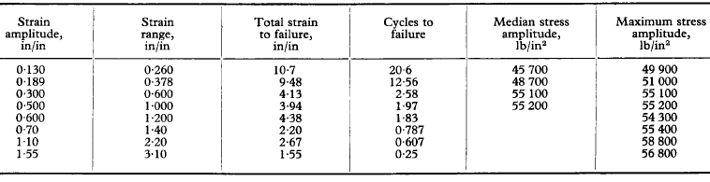

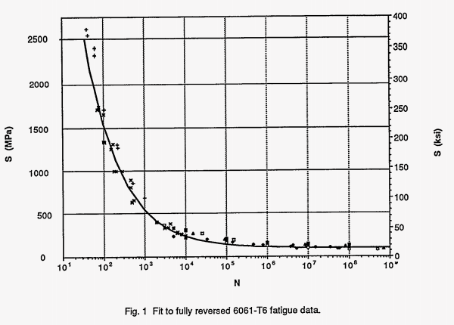

## Maintainability

### Maintainability refers to the degree in which the components of a device are easy and quick to replace. Based from that, the design for the grip mechanism was decided to use quick-connects to make those parts easy to replace in case of failure and also user assembly. Afterwards, the lifting mechanism was considered, which was designed out of 3-D printed materials that offer reliability as mentioned before. Furthermore, the 3-D printed crank lift mechanism would be fully easily replaced through 3-D printed gear assemblies which do not require more than usual equipment such as screwdrivers in order to operate them.

|  |  |
| --- | --- |
| Pre-Determined Materials | Price (US Dollars) |
| Convection Oven | 2000 |
| Transportation Cart | 100 |
| PC System | 500 |
| Total | 2600 |

## Bill of Materials

### The bill of materials was based off mainly from amazon items in order to buy the main electronic components and 3D printed materials at cheap price and fast delivery. Reference A on the Appendix shows the prices for each item and the address link for them. However, that list only shows the items that were selected from the students. The three items that were not considered in school ordering is the PC system, the Convection Oven and the Transportation Cart. These prices can be seen on Table asfdsf that will reflect the majority of the price.

## Engineering Economics

### The income statement for the fictitious company will obtain by selling the Poly-Creep V will have some special considerations. Based on market research, all companies that sell creep testers do not use them as their main source of income. Therefore, analyzing the revenue of a company with only creep testers as their main or only product will not render a profitable company. Thus it was necessary to assume prices of example, light, water, rent etc. to be a fraction of 1/8 of the company. This way the company can see if it is profitable to add up the Poly-Creep V to their inventory. After adjusting for only one product, Table 4 on Reference 3 shows the benefits of selling the Poly-Creep V. Finally, Table 5 on Reference 4 shows the important ratios such as the gross profit margin to see the benefits of implementing the Poly-Creep V.

|  |  |  |
| --- | --- | --- |
| Expenses (Production Costs) | | |
| Labor: | | |
| Labor Price Per Hour | Labor Hours | Total |
| 18 | 60 | 1080 |
| Supervisor Salary | Supervisor Hours | |
| 26 | 12 | 312 |
| Benefits for Employees (vacations, leave, 401k, etc) | | 324 |
| Benefits for Supervisors (vacations, leave, 401k, etc) | | 93.6 |
| Production Volume Per Year | | 150 |
| Number of Employees | (4 Per Device) | 37.5 |
| Total Labor Per Employee | | 1404 |
| Total Labor (37 Employees) | | 51948 |
| Supervisor Salary Total (7 Supervisors) | | 2839.2 |
| Estimated Labor for Production Volume | | 54787.2 |
| Lease: | | |
| Average Price Per Square Foot (Monthly) | Total Area (ft^2) | |
| 23.23 | 660 | 15331.8 |
| Yearly Rent (12 Months) | | 183981.6 |
| Utilities | | |
| Electricity (Monthly) | (1.34 per ft^2) | 884.4 |
| Water (Yearly) | (2.70 per ft^2) | 1782 |
| Electricity (Yearly) | | 10612.8 |
| Total Utilities Cost | | 12394.8 |
| Material Cost | | |
| Oven | | 2000 |
| Computer | | 200 |
| Cart | | 50 |
| Reference Back to Sheet 1 for Parts List | | 399.83 |
| Total Material Cost Per Creep Tester | | 2649.83 |
| Total Cost Yearly for Creep Testers | | 397474.5 |
| Equipment | Quantity |  |
| Soldering Iron | (6 Average Needed) | 30 |
| Bandsaw | 1 | 2700 |
| Grinding Machine | 1 | 400 |
| Basic Assembly Equipment | 1 | 200 |
| Total Equipment | | 3330 |
| Depreciation | | |
| Bandsaw | 10 year linear | 270 |
| Grinding Machine | 10 year linear | 40 |
| Basic Assembly Equipment | 5 year linear | 40 |
| Total Depreciation | | 350 |
| Overhead Expense | |  |
| 30% of Total Labor Cost to Cover up for Insurance, Parking and Other Expenses. | | 30% |
| 16436.16 |
| Total Cost Analysis | | |
| Direct Costs | | 464656.5 |
| Indirect Cost | | 187661.6 |
| Overhead Expense | | 16436.16 |
| Distributors (Estimated from Revenue) | 5% | 37500 |
| Retail Cost (Estiamted from Revenue) | 5% | 37500 |
| Total Cost | | 743754.3 |

|  |  |
| --- | --- |
| Revenues (Product Sales) | |
| Price Per Unit(Estimated) | 5000 |
| Quantity Sold (Estimated) | 150 |
| Sale Revenue | 750000 |

|  |  |
| --- | --- |
| Final Results | |
| Sales Revenue | 750000 |
| Total Cost | 743754 |
| Net Income | 6245.74 |
| Gross Profit | 297738.3 |
| Gross Profit Margin | 40% |

## Cost of Prototype

### Reference A contains the total price for the custom parts that were bought in order to make the Poly Creep V. This amount came out to be 399.83 based from the catalog prices. However, in order to account for the whole value of the prototype, product costs of the PC System, Convection Oven and Transportation Cart had to be included. The total prices added up to a total of 3000 dollars. The item pricing and listings are included in Reference B. Finally, the total calculations for the final cost of the prototype are in Reference C.

## Production Cost

## Manufacturing Process Details

# Design Validation

## Design Failure Mode and Effects Analysis (DFMEA)

### In order to design the Poly-Creep V for Failure Mode and Effect Analysis (DFMEA), certain procedures must be followed in order to create a proper DFMEA. According to the Six Sigma website [], the steps are:

### Design Review – Use the product/service design drawings or documents to identify each component and its relation with other components of product/service

### Brainstorm potential failure modes

### List potential failure modes

### List potential effects of failure modes

### Assign the severity ranking which should be based on consequences of failure (1 to 10) (Threat to human life, accident or safety issue is scored 10)

### Assign the occurrence ranking (1 to 10)

### Assign detection ranking based on the chance of detection prior to failure (1 to 10) (Easy for detection gets less score – 1, difficult to detect should be assigned higher score)

### Calculate the SOD (Severity x Occurrence x Detection) number or risk priority number (RPN)

### Develop action plan to reduce vital RPNs (Above set baseline)

### Implement the improvements identified

### Calculate RPN again based on improvements. Do mistake proofing.

### After reviewing the general design of the Poly-Creep V, several possible methods of failure were considered. The following list, are some of these possible methods of failure.

### Malfunction of the convection oven, possibly producing an overheating of the chamber and the components inside of it.

### Probable heat loss due to an opening of the chamber.

### Interference/malfunction of the thermocouples and/or linear potentiometers.

### Misalignment of the weigh mechanism’s rods with the grips.

### Failure of the load application mechanism due to impact instantly after releasing the loads applied to the specimens.

### Taking in considerations this possible scenarios of failures for the Poly-Creep V, the following table is presented with the Severity, Frequency, Detectability and Risk Priority Number of each failure mode respectively.

|  |  |  |  |  |  |
| --- | --- | --- | --- | --- | --- |
| **Part/Component** | **Failure Mode** | **Severity** | **Frequency** | **Detectability** | **Risk Priority Number** |
| Oven | Overheating | 10 | 1 | 3 | 30 |
| Oven | Significant Heat loss | 4 | 2 | 2 | 16 |
| Sensors | Interference/malfunction | 3 | 3 | 3 | 27 |
| Rods with Grips | Misalignment | 3 | 2 | 1 | 6 |
| Gears | Failure due impact | 2 | 3 | 1 | 6 |

### According to the Risk Priority Number, calculated from the DFMEA, the failure mode that a user most be worried the most, would be through overheating, since its risk priority number is 30, compared to the mode of worst severity, the heat chamber with a severity of 10. In order to solve this problem, the first solution for this failure mode, it will be to check the connections of the linear potentiometers and thermocouples with the Arduino. In case the first solution does not solve the problem, the following solution will involve to check the components individually, in order to run a test to identify the sensor that is malfunctioning, and check if it can be repair or in case that is necessary, change the fail sensor.

## 

* Test Protocols
* Design Documents
* Engineering Calculations
* Manufacturing Process
* Various Materials (User’s, Maintenance, Operations, etc.)

# References

<http://www.gdrc.org/uem/lca/guidelines.html>

<http://www.sciencedirect.com/science/article/pii/S2238785415001234>

<http://www.osti.gov/scitech/servlets/purl/10157028/>

<http://www.reliasoft.com/newsletter/v8i2/reliability.htm>

<http://www.design1st.com/Design-Resource-Library/design_tips/Design_for_Maintainability.pdf>

# Appendices

|  |  |  |  |  |  |
| --- | --- | --- | --- | --- | --- |
| Bill of Materials | | | | | |
| Vendor Source | Quantity | Item Name | Price Per Unit | Price Total | Detail |
| <https://www.amazon.com/gp/product/B008GRTSV6/ref=ox_sc_act_title_1?ie=UTF8&psc=1&smid=A1ZXWJYIISJIMI> | 4 | Arduino | 23.99 | 95.96 |  |
| <https://www.amazon.com/gp/product/B016KI622U/ref=ox_sc_act_title_2?ie=UTF8&smid=A3ANSWWZUKKRT&th=1> | 1 | Cables | 7.89 | 7.89 |  |
| <https://www.amazon.com/gp/product/B0100A7SS6/ref=ox_sc_act_title_5?ie=UTF8&psc=1&smid=A1THAZDOWP300U> | 5 | Module | 8.4 | 42 |  |
| <https://www.amazon.com/dp/B00K95TL74/ref=twister_B00MAK3WEO?_encoding=UTF8&psc=1> | 1 | Filament | 14.49 | 14.49 |  |
| <https://www.amazon.com/dp/B00K95TW2S/ref=twister_B00MAK3WEO?_encoding=UTF8&th=1> | 1 | Filament | 17.17 | 17.17 |  |
| https://www.amazon.com/Automate-Boring-Stuff-Python-Programming/dp/1593275994/ref=s9_cartx_gw_g14_i1_r?_encoding=UTF8&fpl=fresh&pf_rd_m=ATVPDKIKX0DER&pf_rd_s=&pf_rd_r=P5PGQH4M7Y7ZE7VCFVVX&pf_rd_t=36701&pf_rd_p=b21f7431-0e6c-4207-b08b-cc9492e60b0f&pf_rd_i=desktop | 1 | Python Programming Guide | 25.45 | 25.45 |  |
| https://www.amazon.com/Double-side-Prototype-Universal-Printed-Circuit/dp/B0147YM3DG/ref=sr_1_2?ie=UTF8&qid=1478899578&sr=8-2&keywords=circuit+board | 1 | Circuit Board | 5.17 | 5.17 |  |
| <https://www.amazon.com/dp/B00K95TPO8/ref=twister_B00MAK3WEO?_encoding=UTF8&th=1> | 1 | Filament | 16.99 | 16.99 |  |
| https://www.amazon.com/gp/product/B01258UZMC/ref=ox_sc_act_title_1?ie=UTF8&psc=1&smid=A2SSLHUTQUODGT | 1 | Breadboard | 8.99 | 8.99 |  |
| <http://www.mscdirect.com/product/details/35433226> | 3 | Bearing | 7.32 | 21.96 | Part # 35433226 |
| <http://www.mscdirect.com/product/details/35433291?item=35433291> | 3 | Bearing | 17.32 | 51.96 | Part # 35433291 |
| Lowes | 44 | Nuts & Bolts | 0.5 | 22 | Voucher for Bolts from Lowes |
| http://www.homedepot.com/p/Husky-4-Piece-Quick-Connect-Kit-HDA20100AV/100003130?cm_mmc=SEM|THD|google|&mid=sGGzTBmKX|dc_mtid_8903tb925190_pcrid_111416414825_pkw__pmt__product_100003130_slid_&gclid=Cj0KEQiA9ZXBBRC29cPdu7yuvrQBEiQAhyQZ9JmbM0Yj8WBrYptgitnSI2ClfpQuOwaJ4ALDG2e7rBwaApFD8P8HAQ | 5 | Connector Kit | 5.96 | 29.8 | Can Be bought from Lowes or Home Depot |
| Lowes | 1 | Plexiglass | 40 | 40 |  |
|  | 199.64 | | | 399.83 | Total |
| Electrical Department |  | Electrical Wire |  |  |  |
| Home |  | Soldering Iron |  |  |  |
| <https://www.megatron.de/en/products/potentiometric-position-sensors/potentiometric-linear-transducer-series-clp13.html> | 1 | Potentiometers |  |  |  |
| Hi Bay |  | Rods |  |  |  |